**Instructions for executing the project:**

1. Download the ZIP file for the project from here: <https://github.com/beproject1/Email-System-for-Visually-Impaired>

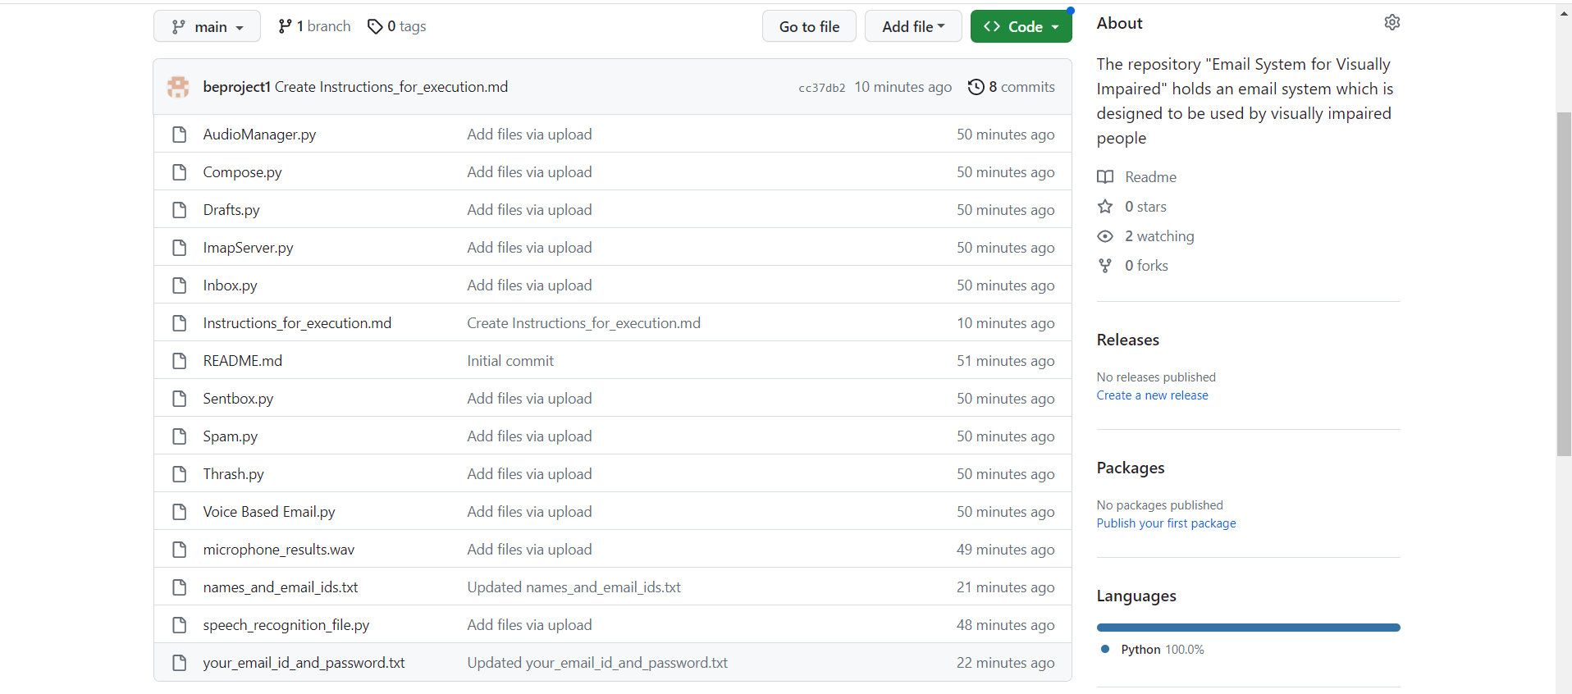

1. Extract the downloaded ZIP file on your computer. After the extraction is done, your directory should look like this:

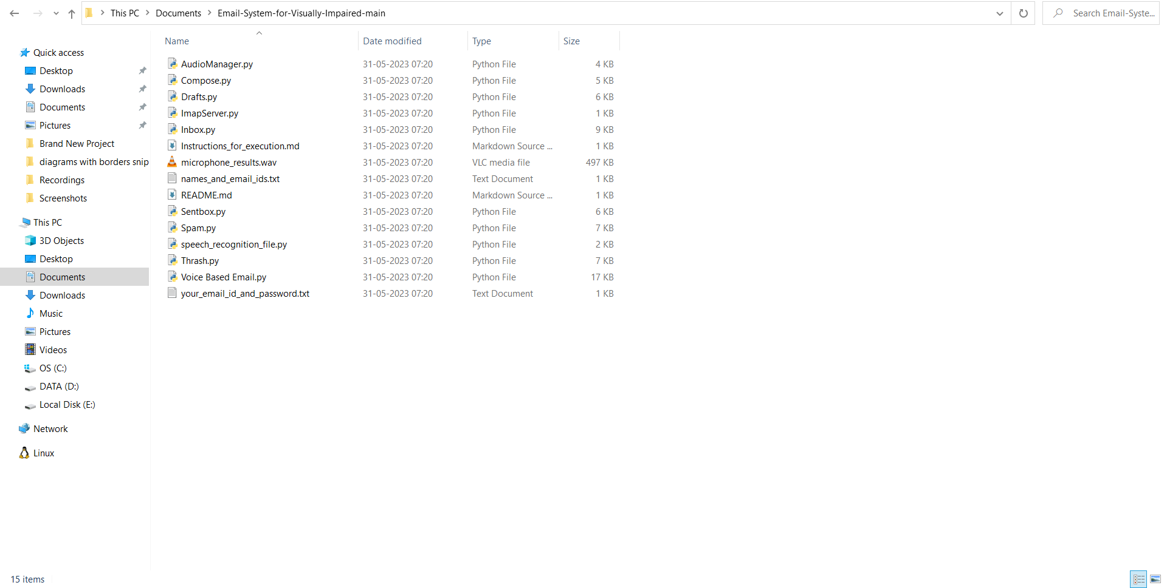

1. Generate a unique app password for your Email Account. For gmail accounts, instructions can be found here: <https://support.google.com/accounts/answer/185833?hl=en>
2. Open the file "your_email_id_and_password.txt" and enter your Email ID and App Password in the respective placeholders
3. Open the file "names_and_email_ids.txt" and enter the Name and Email ID of your contacts in the respective placeholders
4. The file "Voice Based Email.py" acts as the entry-point of the project. Execute the file "Voice Based Email.py" and you are now ready to use the program

Thank you